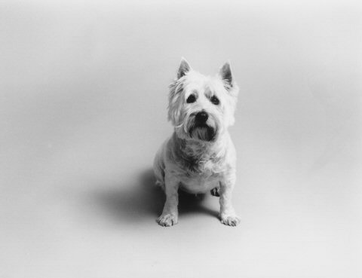
Jenny Desmond Photography
PRICE LIST

UNFRAMED PRINTS

Approximate Size | 1st Print | Addt’l Prints (same size, same negative)
5X7 | $30.00 | $25.00
8X10 | $40.00 | $35.00
11X14 | $50.00 | $45.00
FRAMED, MATTED, SIGNED PRINTS

Print Size | Approximate Frame Size | Price
5X7 | 8X10 | $95.00
8X10 | 11X14 | $110.00
11X14 | 16X20 | $135.00
508.981.7511 jdesmond@jennydesmond.com
Note: Odd size prints and special matting available at an additional charge.
All prints are hand processed on fine art papers.
Framed prints are created using archival glass and matting and are signed by the artist.
Thank you for your business.

Please make checks payable to Jenny Desmond Photography.

©all prints are copyrighted and may not be duplicated.

