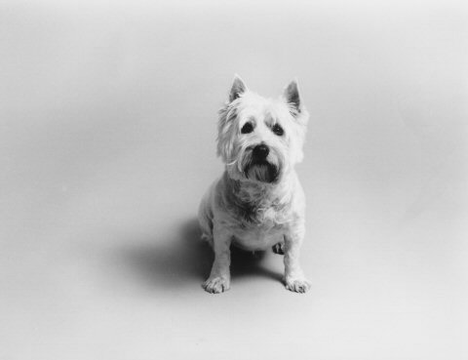
Jenny Desmond Photography

YOUR PHOTO SHOOT
508.981.7511 jdesmond@jennydesmond.com

Notes:

Thank you for your interest in Jenny Desmond Photography! I specialize in black and white family portraiture with an emphasis on canines and their humans.

Photo shoots are interactive and spontaneous - it is important to me that my portraits capture each individual’s true personality and spirit. Photo shoots take place in the studio and are relaxed and fun.

I am happy to photograph individuals or groups. Families of all shapes and sizes are welcome.

My style is spontaneous and relaxed. However, feel free to think about any specific photos you may want, such as certain individuals you want in a photo together or a photo of your pet you have always wanted. I am happy to try and accommodate these ideas.

Dress comfortably. Solid colors are better than detailed prints.

Sitting fee is due on day of shoot.
Thank you for booking a photo shoot!

- The fee for photo shoots is $150. Shoots done outside the studio are an additional $50. One 5x7 print of your choice is included in this fee.

- The photo shoot will last about 1-2 hours.

- I will shoot two to four rolls of film, depending upon your needs.

- Black and white film will be shot, unless otherwise specified.
Following the Shoot:

Following the shoot, film will be processed & proof sheets delivered within 2 weeks.

I will meet with you to discuss which photos you would like & related specifications.

Once prints have been chosen, they will be processed (and, if applicable, framed) and delivered to you within two weeks. An invoice will be included.

Rush jobs are possible, but may involve an additional charge.

